Topic 1
Lab Experiments

Experiment 1: Linear Search (Iterative)

Aim
To implement Linear Search using an iterative approach and analyze its time complexity.

Algorithm
- Start.
- Read the array and key.
- Traverse the array from the first element.
- Compare each element with the key.
- If found, display the index.
- Otherwise display "Key not found."
- Stop.

Output:

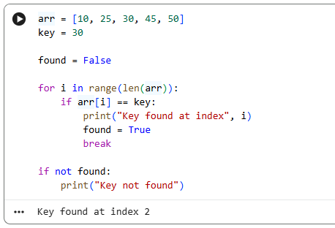

Time Complexity
- Best Case (Ω): O(1)
- Average Case (Θ): Θ(n)
- Worst Case (O): O(n)

Result
The Linear Search algorithm was implemented successfully, and the key element was searched correctly.

Experiment 2: Binary Search (Recursive)

Aim
To implement Recursive Binary Search and analyze its time complexity.

Algorithm
- Start.
- Read the sorted array and key.
- Find the middle element.
- If middle equals key, return index.
- If key is smaller, search left half.
- Otherwise search right half.
- Repeat recursively until found or search space becomes empty.
- Stop.
- 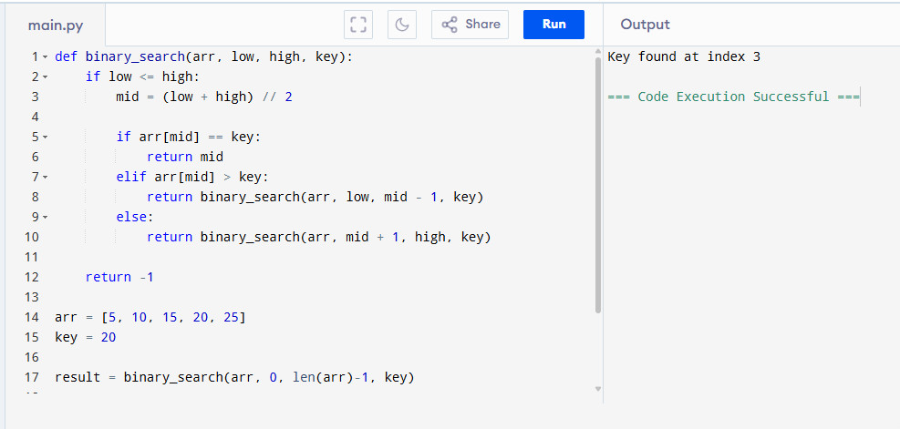

Time Complexity
- Best Case: O(1)
- Average Case: Θ(log n)
- Worst Case: O(log n)

Result
Recursive Binary Search was implemented successfully and located the key efficiently.

Experiment 3: Factorial (Iterative vs Recursive)

Aim
To compare iterative and recursive methods for finding factorial.

Algorithm
Iterative
- Initialize fact = 1.
- Multiply fact by every number from 1 to n.
- Display fact.
Recursive
- If n = 0 or 1, return 1.
- Return n × factorial(n−1).

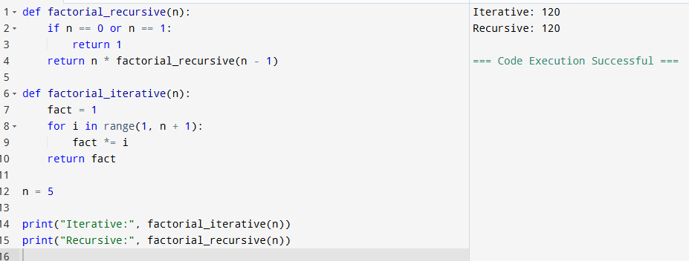

Time Complexity
- Iterative: O(n)
- Recursive: O(n)

Result
Both methods produced the same factorial value successfully.

Experiment 4: Fibonacci Series

Aim
To generate Fibonacci numbers using iterative and recursive methods.

Algorithm
- Read n.
- Generate Fibonacci numbers using iteration.
- Generate Fibonacci numbers using recursion.
- Display the series.
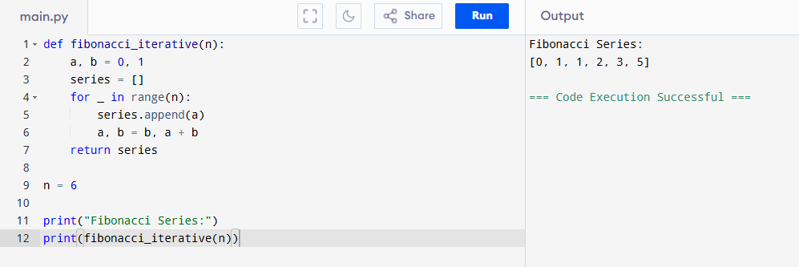

Time Complexity
- Iterative: O(n)
- Recursive: O(2ⁿ)
- Recursive (Memoization): O(n)

Result
The Fibonacci series was generated successfully using both approaches.

Experiment 5: Matrix Multiplication

Aim
To multiply two matrices and analyze nested loop complexity.

Algorithm
- Read two matrices.
- Initialize result matrix.
- Use three nested loops.
- Multiply corresponding elements.
- Store the sum.
- Display result matrix.
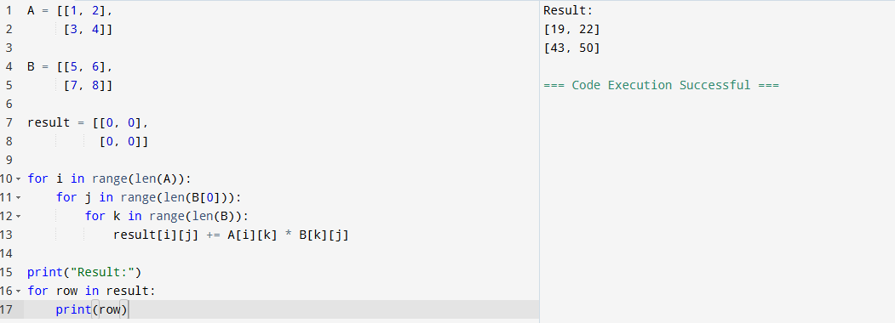

Time Complexity
O(n³)

Result
Matrix multiplication was performed successfully.

Experiment 6: Merge Sort

Aim
To implement Merge Sort using Divide and Conquer.

Algorithm
- Divide array into two halves.
- Recursively sort each half.
- Merge sorted halves.
- Display sorted array.
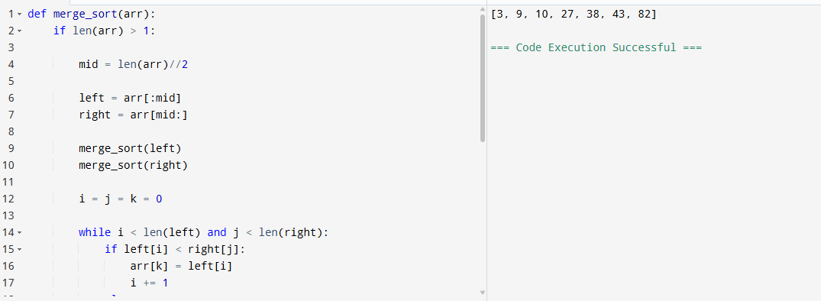

Time Complexity
- Best: O(n log n)
- Average: O(n log n)
- Worst: O(n log n)

Result
Merge Sort successfully sorted the array.

Experiment 7: Quick Sort

Aim
To implement Quick Sort and analyze pivot selection.

Algorithm
- Choose pivot.
- Partition array.
- Place pivot correctly.
- Recursively sort left and right subarrays.

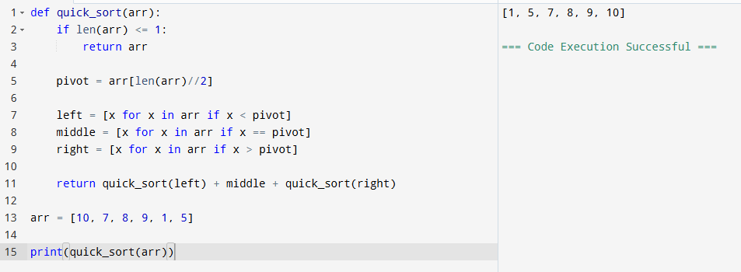

Time Complexity
- Best: O(n log n)
- Average: Θ(n log n)
- Worst: O(n²)

Result
Quick Sort sorted the array successfully.

Experiment 8: Tower of Hanoi

Aim
To solve the Tower of Hanoi problem using recursion.

Algorithm
- Move n−1 disks to auxiliary rod.
- Move largest disk.
- Move n−1 disks to destination rod.
- Repeat recursively.

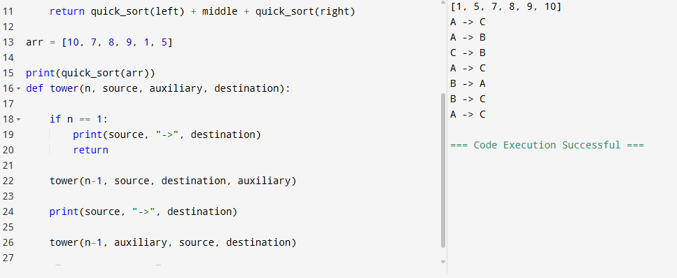

Time Complexity
O(2ⁿ)

Result
The sequence of moves was generated successfully.

Experiment 9: GCD (Euclidean Algorithm)

Aim
To find the Greatest Common Divisor using Euclid's Algorithm.

Algorithm
- Read a and b.
- If b = 0, return a.
- Otherwise compute GCD(b, a mod b).
- Repeat recursively.

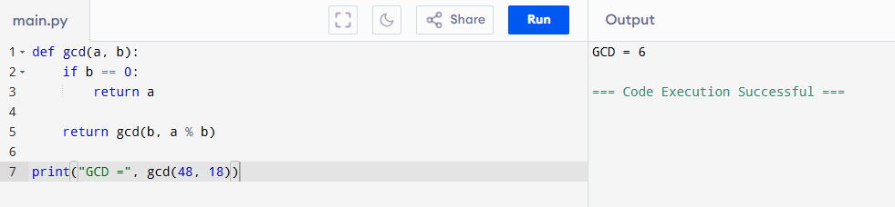

Time Complexity
O(log n)

Result
The Greatest Common Divisor was calculated successfully.

Experiment 10: Insertion Sort

Aim
To implement Insertion Sort and analyze its complexity.

Algorithm
- Start from second element.
- Compare with previous elements.
- Shift larger elements.
- Insert at correct position.
- Repeat until sorted.

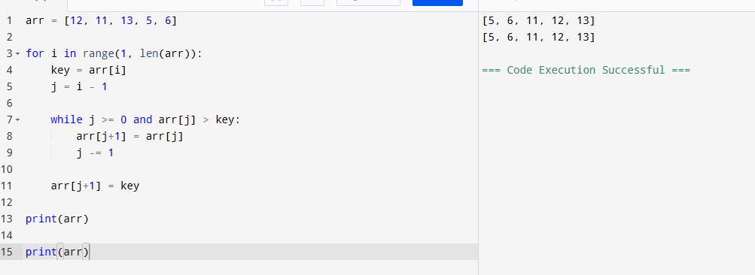

Time Complexity
- Best: O(n)
- Average: Θ(n²)
- Worst: O(n²)

Result
Insertion Sort arranged the elements in ascending order successfully.

Experiment 11: Heap Sort

Aim
To implement Heap Sort using a Binary Heap.

Algorithm
- Build max heap.
- Swap root with last element.
- Reduce heap size.
- Heapify again.
- Repeat until sorted.

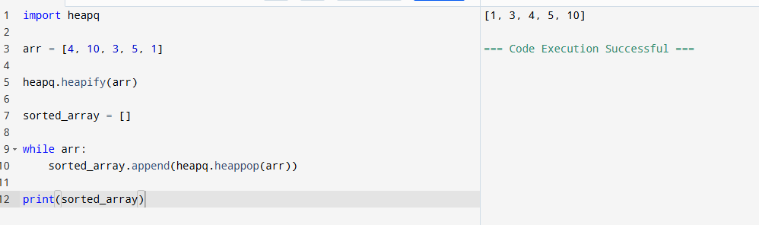

Time Complexity
- Best: O(n log n)
- Average: O(n log n)
- Worst: O(n log n)

Result
Heap Sort successfully sorted the array.

Experiment 12: Counting Inversions

Aim
To count inversions using Modified Merge Sort.

Algorithm
- Divide array.
- Count inversions in left half.
- Count inversions in right half.
- Count split inversions while merging.
- Add all counts.

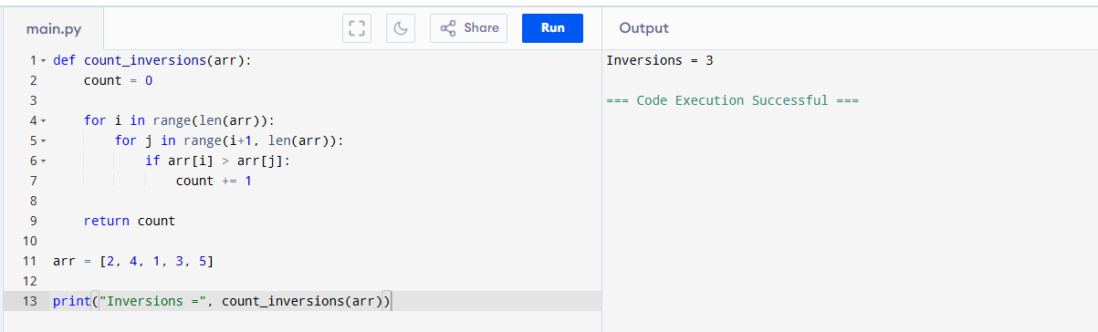

Time Complexity
O(n log n)

Result
The total number of inversions was counted successfully.

Experiment 13: Maximum Subarray Sum

Aim
To find the maximum subarray sum using Kadane's Algorithm.

Algorithm
- Initialize current sum and maximum sum.
- Traverse array.
- Update current sum.
- Update maximum sum.
- Display maximum sum.

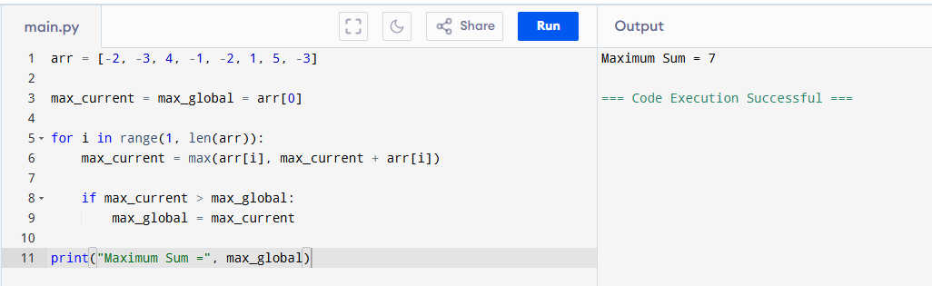

Time Complexity
- Kadane's: O(n)
- Divide & Conquer: O(n log n)

Result
The maximum subarray sum was found successfully.

Experiment 14: Exponentiation

Aim
To compute xⁿ using iterative and recursive fast exponentiation.

Algorithm
Iterative
- Multiply x repeatedly n times.
Recursive Fast Power
- If n = 0 return 1.
- Compute power recursively for n/2.
- Square the result.
- Multiply by x if n is odd.

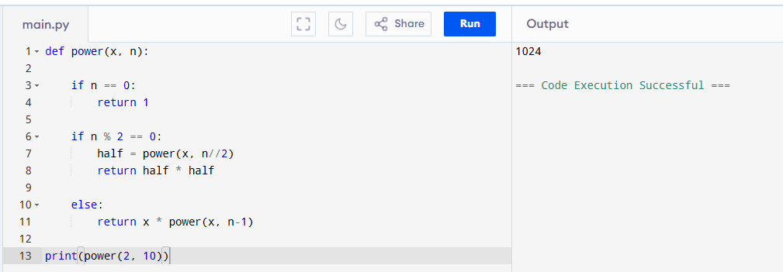

Time Complexity
- Iterative: O(n)
- Fast Exponentiation: O(log n)

Result
The power of the given number was calculated successfully.

Experiment 15: Closest Pair of Points

Aim
To find the closest pair of points in a 2D plane.

Algorithm
- Compute distance between every pair of points.
- Keep track of minimum distance.
- Display closest pair.

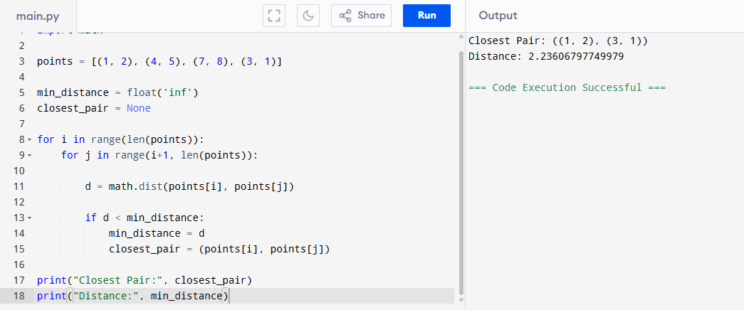

Time Complexity
- Brute Force: O(n²)
- Divide & Conquer: O(n log n)

Result
The closest pair of points and the minimum distance were found successfully

